Air Travel is Safe!

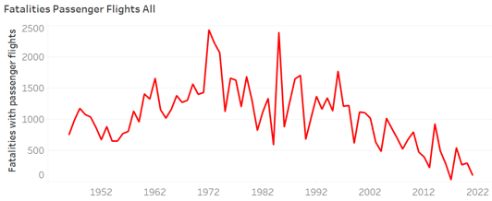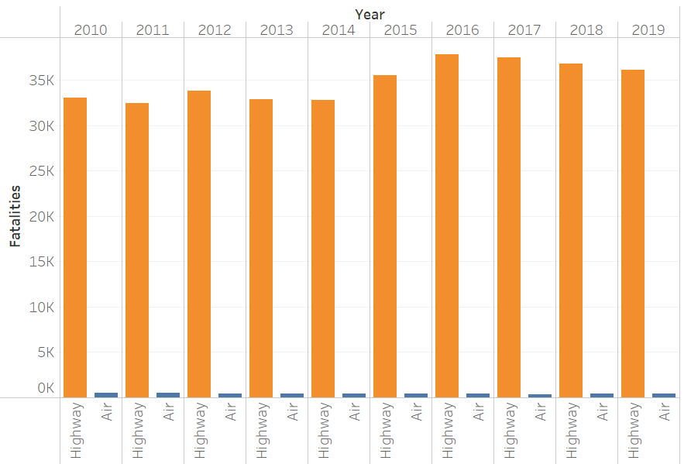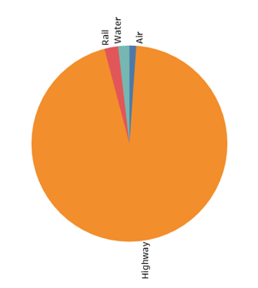

Citation: Lesser Lesser Landy &amp; Smith PLLC. “The Question Is Often Asked, ‘Is Flying Safer than Driving?” Lesser Lesser Landy &amp; Smith PLLC, https://www.lesserlawfirm.com/is-flying-safer-than-driving

Don’t even look at the numbers of car fatalities anymore. The time series chart to the right shows that since the 1970’s, there has been a downward trend of Air Travel fatalities. Currently dying from an Air Travel related incident is very rare in most cases. #TheTruthAboutAirTravelSafety

Looking further back from 2019, Air and Highway travel can be compared going back to 2010. It is obvious that Highway travel has many times as many fatalities per year compared to Air travel. Lesser Lesser Landy & Smith Law Firm estimates that the odds of dying in a plane crash are 1 in 9,821. That is about 1 fatality per 16 million flights. Where the odds of dying in a car crash are approximately 1 in 114 #TheTruthAboutAirTravelSafety

To the right is a pie chart that displays the ratio of all main transportation related fatalities for the year 2019. The largest percentage of all fatalities from 2019 were highway travel related incidents. Air travel had the least number of fatalities in 2019. #TheTruthAboutAirTravelSafety

Recently the airline industry has been under attack from media outlets claiming that air travel is becoming increasingly unsafe! As horrible as this is to hear, lets have you take a look at some data and decide for yourself… #TheTruthAboutAirTravelSafety